Casey Faggion
fagck001
Secure Software Development
Assignment 1
Contents
Executive Summary 2
Vulnerability Type 2
Vulnerability Instance 2
Remediation 2
Automated security testing 2
Recommendations 2
Conclusion 2
References 2

Executive Summary

Introduction
This report discusses what SQL injection is, how it can be exploited, and what the specific instances of it within the Guardian store are. The vulnerability is very common, according to OWASP, and is usually present because of mishandled database queries. In the Guardian Store, it is present within the item search bar, and the user login page. It will discuss typical remediation of this vulnerability, and how it can be tested for automatically.

Vulnerability Type
SQL injection (SQLi) is a very common type of vulnerability, having been present on almost every iteration of the OWASP top ten since its inception. When users interact with a web application in a way that requires a request to be sent to the database (ex. Searching for an item, logging in), a query is used to define what information should be retrieved from the database is used, and this query is typically where this vulnerability will present. A simplified database query might look like this:
‘SELECT * FROM Users WHERE email = ‘ + emailValue + ‘ AND password = ‘ + passwordValue
When this query is excuted, the ‘emailValue’ and ‘passwordValue’ fields are substituted with the user-supplied values – in this case, the email and password entered by the user. In the intended flow, the query would match the supplied email to a matching email in the database (if one is found) and check the user-supplied password to ensure it matched with the password in the database. Using string concatenation – directly inserting the user values with the ‘+’ character – to insert the values creates significant risk, as certain characters that have specific functions within SQL queries can be used to alter the intended behaviour of the code. For example, the user passing in a single quote as the start of their email would effectively end the string and have the rest of their ‘email’ be treated as actual query code rather than simply a string of characters.
Users’ entered email: ‘ OR 1=1--
This email would effectively be inserted to the query as such:
‘SELECT * FROM Users WHERE email = ‘ OR 1=1 -- AND password = ‘ + passwordValue
Because the string is ended with the single quote, and a statement that always evaluates to true (in this case, 1=1) is used to bypass the check for the users’ email, and the double minus nullifies the remaining code on the line, removing the password check. This would retrieve the first listed account in the ‘user’ database table, which is often an admin account, as is the case in the Guardian store.
SQL injection usually arises because of the way user input is handled. In cybersecurity, there exists a different ‘trust zones’, wherein the data and requests made are treated with a level of trust respective to their zones. In the Guardian store application, any internal server or database requests are treated as trusted – meaning that they are assumed to not be malicious. This can be thought of as the different doors within a house: the front door is locked, but once you are inside the house, the internal doors are not locked because it is assumed that by being inside the house, you can be trusted. This same principle is frequently applied to web applications to determine how certain data is treated.
The requests being made to the database to retrieve data are within a trusted zone; the requests are assumed to not be malicious. However, the issues arises when an untrusted party can pass in data to this trusted request, potentially manipulating it to their own gain. Because the user can directly pass in their data into the query, a significant risk arises due to the untrusted data being treated as trusted.
Attackers versed in exploiting SQLi vulnerabilities can wreak havoc, gaining access to sensitive personal data, modify or delete data, gain admin privileges, or even crash the server. Having an application suffer any of these attacks can also cause devastating reputational damage to the company.

Vulnerability Instance
Any web application feature that requires information to be retrieved from the database will require a query to get the information. Given this information, it can help understand what areas may potentially be vulnerable. In the Guardian store, features like the login flow and search bar require data to be retrieved from the database (note: the register flow may seem like a vulnerability, but this does not ‘get’ information, instead posting information to the database, eliminating it as a potential SQLi attack surface).
First, the login flow was exploited using a basic attack: ‘ OR 1=1--
Inserting this string into the username section of the login with any password granted access to the first account in the ‘users’ table in the database, which is the admin account. The ability to gain access to the Guardian admin account with the most basic of SQLi attacks reveals how severe the vulnerability is, and the potential damage inflicted by a malicious agent. Reviewing the source code, the query is notably like the example used in the previous report section:
While it does not directly use string concatenation, it uses a format string that instead uses the ‘${}’ markers to determine where user values are inserted, presenting the same vulnerability.
Moving to the search bar, the second obvious attack surface, it was probed using some more basic SQLi payloads to help understand how queries were handled on the backend. While the search bar does not reveal any potential vulnerabilities by inserting payloads directly into the search bar, instead inserting the payload string “’;” directly into the REST URL request (http://localhost:3000/rest/products/search?q=';) reveals an error:
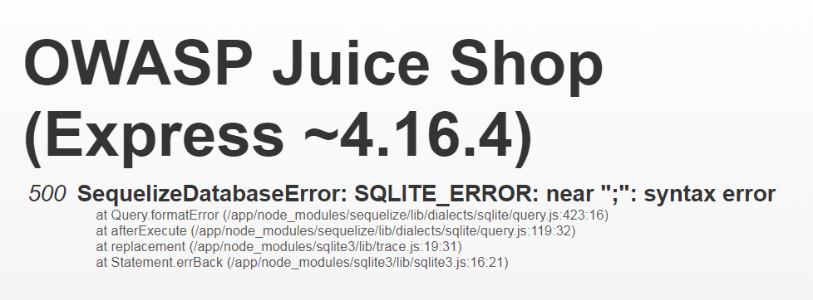\
This error being returned indicates that ‘blind’ SQLi attacks are possible, meaning crafting an effective payload only requires reading the error and some persistence. Attempting to use a different character string – “’-- “ produces a new error: SQLITE_ERROR: Incomplete input. Some more probing reveals that inserting “’))—” retrieves all products, including deleted products, and allows the user to add them to the basket and purchase them.
Reviewing the source code to reveals this:
A retrieval query essentially the same as the login query. While the ability to retrieve and buy deleted objects may not at first seem like a severe issue, a more experienced attacker can leverage weaknesses like there to significant gain, such as database exfiltration or even deleting entire database tables.

Remediation
Given the long history of SQLi attacks, several design patterns have arisen to combat it. One of the most prevalent is parameterised queries, where user-values are inserted as parameters, rather than directly inserting them into a query. Refactoring the login flow to implement this pattern looks like this:
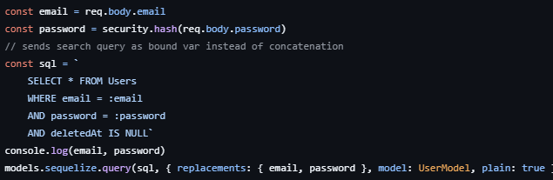
Given that this vulnerability most commonly arises because of directly inserting user-entered values, the most sensible way to handle it is by not directly inserting it into queries, but instead by using string interpolation and checking the entered information to see if it contains potentially harmful characters. The refactoring of the code to instead pass the user-values as a parameter, rather than directly inserting it – is known as query parameterisation.
Parameterised queries are an established design pattern for the treatment of SQL injection vulnerabilities, which is the primary factor in the choice to apply it to the Guardian store.

Automated security testing
Automated security testing is the process of employing specific tools and techniques throughout the software development lifecycle (SDLC) to assess the security of applications by attempting to exploit certain vulnerabilities within the system. Testing tools typically come in three varieties: static application security testing (SAST); dynamic application security testing (DAST); and interactive application security testing (IAST).
SAST scans the application in a non-running state, analysing the source code, dependencies, and byte code for vulnerabilities in the software dependencies, user input, and backdoors. This form of testing is typically leveraged during the early stages of development. DAST tests the application in a running state, simulating attacks against the applications, attempting to find weaknesses in run-time, like session management, cookies, and SQL injection. DAST excels at testing application resilience in an environment like production. Finally, IAST combines aspects of both types, analysing data flow and application behaviour during runtime, specialised in detecting issues that appear during execution.
The critical importance and challenges of implementing automated security testing during the SDLC. Thorough, manual security testing is an exercise that is costly in resources and time, creating issues with the modern Agile style working cadence of many development teams, creating a bottleneck on production. Because of this, new automated tools that can be adjusted to work in-sync with the cadence of development teams and integrate into the continuous integration/continuous deployment (CI/CD) pipeline must be employed to enable development teams to reliably deploy software without crippling team workflows or application security. Thus, automated testing tools have become prevalent among software developers due to their ability to scale production, maintaining consistent testing as systems grow more complex and more interconnected. Additionally, automated testing bypasses the need for specialised experts, creating more consistent results because the tester’s skill is no longer a factor, and CI/CD integration results significantly faster than manual testing.
Employing automated testing throughout the SDLC also reduces costs, as issues identified earlier in development are significantly cheaper to fix, as shown in figure 1. Despite the substantial initial costs on implementing automated testing, the ability to clearly and consistently identify bugs – particularly early in the development cycle – can save organisations significant funds in fixing bugs identified in later development stages.
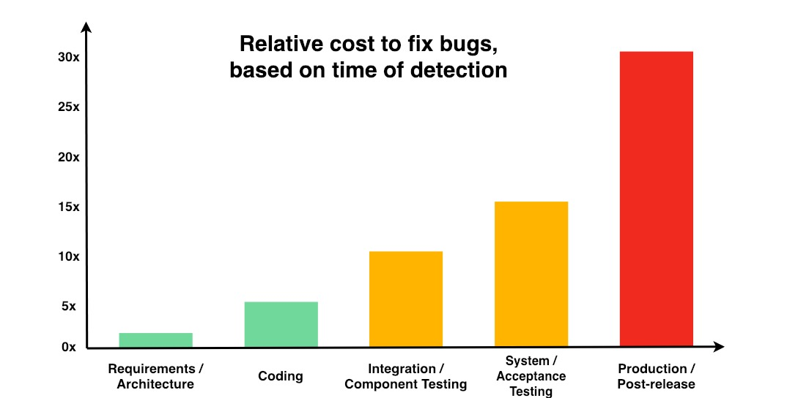
(Fig. 1, DZone)
Given this report’s focus on SQLi, sqlmap was an appropriate choice because it is a tool specialised for detecting and exploiting SQLi vulnerabilities, including the ability to automate its usage into the SDLC. While there are several tools available that can scan for SQLi, sqlmap can scan almost all varieties of relational databases, and tests using several different injection techniques like UNION queries; Boolean-based blinds; error-based; and several others. This variety of exploitation techniques
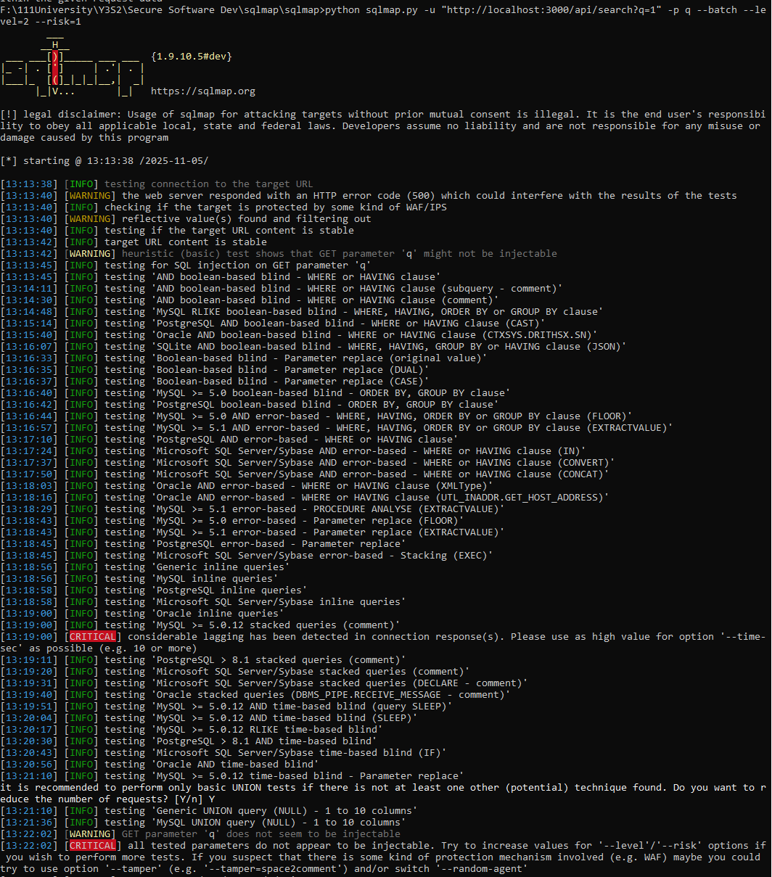

Recommendations

Conclusion
SQL injection is very common vulnerability that can cause devastating damage to the entire system if left unchecked. However, with proper application of secure design principles and automated testing in place, this vulnerability can be minimised for the working life of the platform.

References
https://owasp.org/www-project-top-ten/
https://www.researchgate.net/publication/382737843_Automating_Security_Testing_Strategies_for_Vulnerability_Scanning_Penetration_Testing_and_Compliance_Checks
https://sqlmap.org/
https://www.geeksforgeeks.org/sql/sql-injection/

